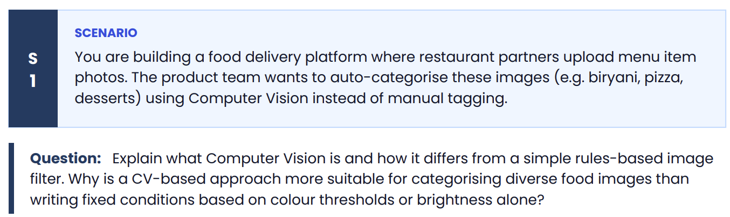
What Computer Vision Is
Computer Vision (CV) is a field of AI that enables machines to interpret and understand visual information from images or video — extracting meaningful patterns (shapes, textures, objects, spatial relationships) the way a human eye and brain would, rather than just reading raw pixel values.
Modern CV systems, especially deep learning-based ones (like Convolutional Neural Networks), learn what defines a category (e.g. "biryani" or "pizza") by being trained on thousands of labeled example images. Through this training, the model automatically discovers relevant visual features — grain texture, garnish patterns, plate shape, sauce color gradients, layering — without a human explicitly programming what those features are.
How This Differs From a Rules-Based Image Filter
A rules-based filter works on fixed, hand-coded conditions — things like:
- "If average pixel brightness > X, classify as Y"
- "If the dominant color is red-orange, it's probably a tomato dish"
- "If saturation is low, it's probably rice"
These rules are written manually by a developer based on assumptions about what the images will look like.
Aspect | Rules-Based Filter | Computer Vision (ML/DL)
Logic source | Human-defined thresholds | Learned from data
Adaptability | Static — breaks on new cases | Generalizes to new, unseen images
Feature detection | Simple (color, brightness, edges) | Complex (shape, texture, context, composition)
Maintenance | Requires manual rule updates | Improves with more training data
Scalability | Poor across diverse categories | Scales well across many classes
Why CV Is More Suitable for Food Image Categorization
Food photos on a delivery platform are highly variable and unpredictable in ways that break simple color/brightness rules:
- Visual overlap between categories — A tomato-based curry and a pizza can share similar red-orange tones and brightness. Color alone can't distinguish them.
- Huge intra-category variation — Biryani photos differ wildly: different plating, garnishes, lighting, camera angles, portion sizes, and regional variations (Hyderabadi vs. Kolkata biryani look different). A fixed brightness threshold can't capture "biryani-ness."
- Inconsistent photo conditions — Restaurant partners upload photos taken with different phones, lighting (dim restaurant lighting vs. bright daylight), angles, and backgrounds. Rules based on brightness/color would misfire constantly because they conflate lighting conditions with actual food identity.
- Need for structural/textural understanding — Distinguishing desserts from curries often depends on shape, texture, and context (a bowl vs. a plate, glossy frosting vs. matte gravy) — not just color statistics.
- Scalability to new categories — Adding a new cuisine type with a rules-based system means writing new hand-crafted logic and hoping it doesn't conflict with existing rules. A CV model just needs more labeled training examples and can learn the new pattern.
- Robustness to noise — CV models (particularly CNNs) learn hierarchical features — edges → textures → shapes → object parts → whole objects — making them resilient to variations in lighting, angle, and background clutter that would completely break a brightness/color threshold approach.
In short: color and brightness are weak, unstable signals that vary with photography conditions, not just food identity. CV models learn robust, discriminative features directly from real-world examples, making them far better suited to the messy, diverse, real-world photo uploads typical of a food delivery platform.

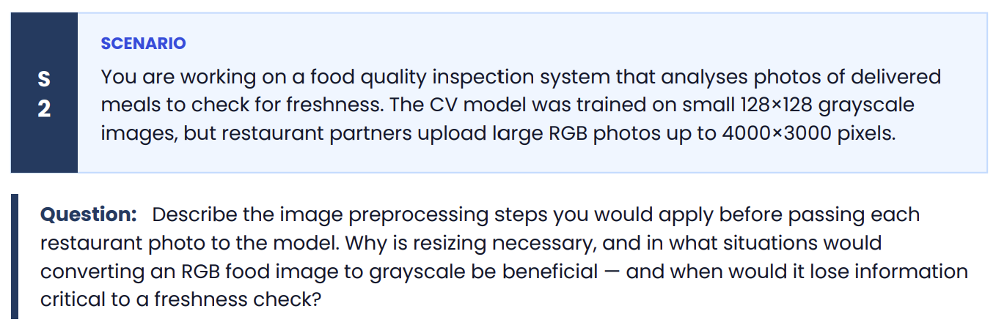
Preprocessing Pipeline
Before feeding a restaurant-uploaded photo (up to 4000×3000 RGB) into a model trained on 128×128 grayscale images, I'd apply these steps in order:
1. Format/Integrity Validation
- Verify the file is a valid, uncorrupted image (JPEG/PNG/HEIC etc.)
- Handle EXIF orientation metadata so the image isn't accidentally rotated 90°/180°
2. Color Space Conversion (RGB → Grayscale)
- Convert using a weighted luminance formula (e.g., 0.299R + 0.587G + 0.114B) rather than simple averaging, since it better matches human perceptual brightness and preserves contrast better.
3. Resizing to 128×128
- Typically done with downsampling using interpolation (bilinear or area-based/INTER_AREA for shrinking) rather than nearest-neighbor, to avoid aliasing artifacts and preserve overall structure while reducing resolution.
- If aspect ratio differs from square, decide between: center-crop, padding (letterboxing), or direct squish — center-crop is usually preferred for food photos to avoid distorting shapes.
4. Normalization
- Scale pixel values from [0, 255] to [0, 1] or standardize to match the mean/std the original model was trained on. This ensures numerical stability and consistency with training distribution.
5. Noise Reduction (optional but recommended)
- Light Gaussian blur or denoising, especially if photos come from varied phone cameras with compression artifacts, since downsizing can amplify JPEG compression noise.
6. Batch/Tensor Formatting
- Reshape into the tensor shape the model expects (e.g., [1, 128, 128, 1] for grayscale single-channel batch input).

Why Resizing Is Necessary
- Model architecture constraint — CNNs (especially non-fully-convolutional ones with dense layers) expect a fixed input shape. A 4000×3000 image simply won't fit the input tensor the model was built and trained for.
- Computational efficiency — Processing a 4000×3000 image is orders of magnitude more expensive (in memory and compute) than a 128×128 one. At scale (thousands of delivery photos per hour), this matters enormously for latency and cost.
- Consistency with training distribution — The model learned patterns at 128×128 resolution. Feeding it differently-scaled input without resizing would produce meaningless or degraded predictions, since the learned filters/weights are calibrated to that scale.

When Grayscale Conversion Helps
Converting RGB → grayscale can be beneficial when:
- The distinguishing feature is structural, not color-based — e.g., detecting mold texture, surface wrinkling, structural collapse of a dish, or wilting shapes where texture and edges matter more than color.
- Reducing computational load matters — grayscale is 1 channel vs. 3, cutting compute and memory by ~3x, useful if the system needs to process high volumes quickly.
- Lighting/color inconsistency across photos is a problem — different phone cameras and lighting conditions introduce color temperature variance (yellowish indoor lighting vs. bluish daylight). Grayscale sidesteps this color noise if it's not diagnostically useful.
When Grayscale Conversion Loses Critical Information
For a freshness check specifically, grayscale can be actively harmful because:
- Color IS the primary freshness signal for many foods:
  - Browning of cut fruits/avocados (oxidation)
  - Greying of meat surfaces
  - Discoloration of leafy greens (green → yellow/brown)
  - Color shift in cooked rice/dairy items indicating spoilage
  - Mold often first appears as a color anomaly (green/black/white spots) before it becomes texturally obvious
- Similar textures, different meanings — A fresh curry and a spoiled curry can have near-identical texture/shape but differ starkly in color (vibrant orange vs. dull brown-grey). Grayscale would erase this distinction entirely.
- Subtle spoilage cues are low-contrast in luminance — Many early-stage spoilage indicators (slight yellowing, faint mold spots) have very close brightness values to the surrounding fresh food, but very different hue/saturation values. Converting to grayscale can make these cues nearly invisible.
Practical recommendation for this specific use case: Since freshness detection heavily depends on color cues (browning, discoloration, mold), I would keep the RGB channels rather than converting to grayscale, and instead resize while preserving 3-channel color — retraining or fine-tuning the model on RGB 128×128×3 input rather than forcing grayscale conversion. Grayscale would only make sense here if a separate ablation study showed color contributed negligible predictive value, which is unlikely for a freshness-specific task.

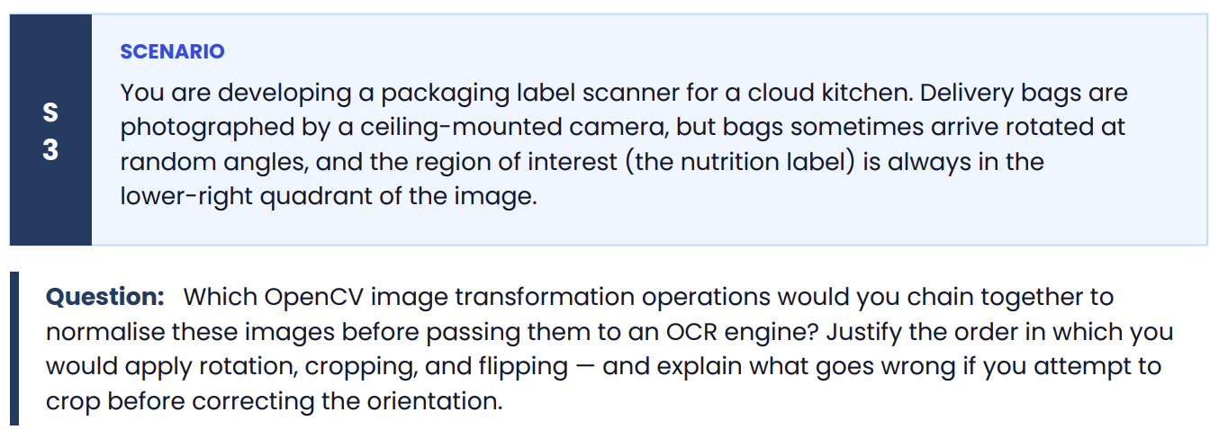
Preprocessing Chain for the Label Scanner
Given: ceiling-mounted camera, bags arrive at random rotation angles, and the nutrition label ROI is defined as "lower-right quadrant" — but that spatial definition is only true relative to the bag's correct upright orientation, not relative to the raw image frame.
The Operation Chain
1. Orientation Detection
- Detect the bag's rotation angle before doing anything else. Depending on what's available:
  - If the bag has a detectable reference feature (printed logo, straight edge, barcode), use cv2.minAreaRect() on the bag's contour (after cv2.findContours()) to get the angle of the minimum bounding rectangle.
  - Alternatively, use edge detection (cv2.Canny) + cv2.HoughLines() to find dominant straight edges of the bag and compute their deviation from horizontal/vertical.
2. Rotation Correction
- Compute the rotation matrix with cv2.getRotationMatrix2D(center, angle, scale) and apply cv2.warpAffine() to rotate the entire image back to the bag's canonical upright orientation.
- Use the entire frame, not a cropped subregion, so no part of the bag or label is cut off during the rotation.
3. Flipping (if needed)
- If the bag can land either face-up in two possible stable orientations (e.g., 0° or 180° symmetric placement, or mirror-flipped if it can land upside-down), determine orientation via an asymmetric reference marker (logo, text baseline direction) and apply cv2.flip() (horizontal, vertical, or both) to normalize left/right and top/bottom.
- This must happen after rotation correction, since flip logic assumes the image is already axis-aligned — you can't reliably tell "is this upside down" from a tilted frame.
4. Cropping to ROI
- Only now, with the image rotated and flipped into a canonical, consistent orientation, crop the lower-right quadrant using fixed/relative coordinates: image[height//2:height, width//2:width] (or a more precisely calibrated bounding box for the label region).
5. Post-crop cleanup for OCR
- Convert to grayscale (cv2.cvtColor(..., cv2.COLOR_BGR2GRAY)) since OCR engines like Tesseract work better on grayscale/binarized text.
- Apply adaptive thresholding (cv2.adaptiveThreshold) or Otsu's binarization to increase text-background contrast.
- Optionally deskew/denoise further if the label itself has minor tilt.
- Resize/upscale if the cropped label region is too small for reliable OCR character recognition.
Order Summary
Orientation Detection → Rotation Correction → Flip Correction → Crop ROI → Grayscale/Threshold → OCR

Why Order Matters: Rotation/Flip Must Precede Cropping
The core issue: "lower-right quadrant" is a statement about the bag's canonical frame, not the camera's frame.
If you crop before correcting orientation:
- You crop the wrong region entirely. If a bag is rotated 90°, what is actually the "lower-right" of the bag (where the label physically is) might now be sitting in the upper-right or upper-left of the raw camera image. A fixed-coordinate crop based on the assumption "label is always lower-right" will grab empty bag surface, a different label/logo, or nothing useful at all.
- Rotation after cropping can't recover lost content. If you crop first and the label was partially or fully outside your (wrongly-positioned) crop box, no amount of rotating that crop afterward will bring back the missing label pixels — they were discarded in step one. Rotation cannot restore information a bad crop already threw away.
- Cropped-then-rotated images introduce padding/border artifacts. Rotating a small, already-cropped patch (rather than the full image) means warpAffine has to fill in corners with black/transparent padding since the crop boundary doesn't align with the rotated content — potentially clipping label edges or introducing artificial borders that confuse OCR.
- Compounding error: Any error in the assumed crop location (based on wrong orientation) directly translates to OCR failure downstream, since the OCR engine will either see no text, partial text, or unrelated bag surface/text.
In short: rotation and flip normalization establish a consistent, predictable coordinate system for the image. Only once that canonical frame exists does a fixed-position crop rule ("lower-right quadrant") become geometrically meaningful. Cropping first bakes in the assumption that the raw camera frame already matches canonical orientation — which is precisely the assumption this scenario says is false (bags arrive at random angles).

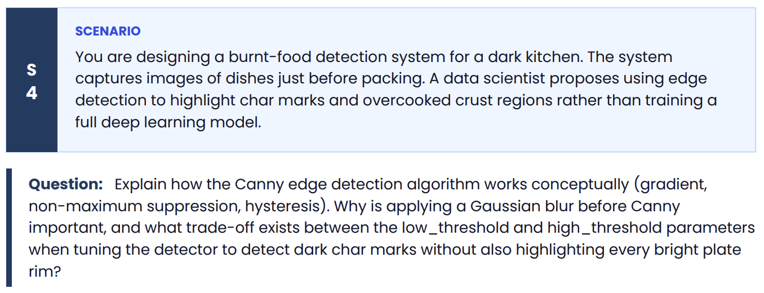
How Canny Edge Detection Works
Canny is a multi-stage algorithm designed to find edges (rapid intensity changes) while suppressing noise and producing thin, well-localized edge lines. It has four conceptual stages:
1. Gradient Calculation
- The (blurred) image is convolved with derivative filters — typically Sobel kernels — in the x and y directions to compute the intensity gradient at each pixel:
  - $G_{x}$= horizontal gradient (rate of change left-right)
  - $G_{y}$= vertical gradient (rate of change top-bottom)
- From these, compute:
  - Gradient magnitude: $G=\sqrt{G_{x}^{2}+G_{y}^{2}}$— how strong the intensity change is (i.e., how "edge-like" a pixel is)
  - Gradient direction: $θ=arctan⁡(G_{y}/G_{x})$— which way the edge runs
- High-magnitude regions correspond to sharp transitions — e.g., the boundary between a charred crust and lighter food surface.
2. Non-Maximum Suppression (NMS)
- Raw gradient magnitude produces thick, blurry edge bands, not clean lines — many neighboring pixels along an edge all have high gradient values.
- NMS thins these down: for each pixel, compare its gradient magnitude to its two neighbors along the gradient direction (perpendicular to the edge). Only keep the pixel if it's a local maximum in that direction; suppress (zero out) the rest.
- Result: edges become single-pixel-wide, precisely localized lines instead of smeared bands.
3. Double Thresholding + Hysteresis
- Two thresholds are applied to the thinned gradient magnitudes: low_threshold and high_threshold.
  - Pixels with gradient magnitude above high_threshold → marked as strong edges (definitely real).
  - Pixels below low_threshold → discarded entirely (definitely not edges, likely noise).
  - Pixels in between → marked as weak edges (ambiguous — could be real edge or noise).
- Hysteresis linking: a weak edge pixel is kept only if it's connected (8-connectivity) to a strong edge pixel, directly or through a chain of other weak pixels. Isolated weak pixels not connected to any strong edge are discarded.
- This produces continuous, meaningful edge contours rather than fragmented noise specks — critical for tracing the full outline of a char mark rather than getting scattered dots.

Why Gaussian Blur Is Applied Before Canny
Canny is fundamentally a gradient-based, derivative operation — and derivatives amplify high-frequency content, which includes both real edges and noise.
Food surface images are naturally noisy: sensor noise, subtle texture variation in sauce/oil sheen, steam, small crumbs, uneven lighting — all create small pixel-to-pixel intensity fluctuations. Without smoothing, the gradient calculation would treat all this micro-noise as edges, producing a cluttered, unusable result (essentially "edge everywhere").
Gaussian blur pre-processing:
- Smooths out small-scale noise while preserving larger, genuine structural transitions (like the crust/char boundary).
- Reduces the number of spurious weak edges that hysteresis would otherwise have to sort through.
- The blur kernel size (σ) controls this trade-off: too small a blur and noise still leaks through as false edges; too large a blur and it smooths away real, fine edges too (like small char speckling), reducing sensitivity to genuinely charred spots.
For char-mark detection specifically, you'd want a moderate blur — enough to suppress camera/sensor noise and oil-sheen texture, but not so much that small burnt speckles blur into the surrounding crust and disappear before the gradient stage even sees them.

The Threshold Trade-off: Detecting Char Without Flagging Plate Rims
This is the crux of tuning Canny for this specific use case.
high_threshold (strong edge cutoff):
- Set too low → picks up every moderately strong intensity transition as a "definite" edge — including the bright plate rim (which typically has strong contrast against the table/background or food), decorative garnish edges, cutlery reflections, steam wisps, etc. This produces false positives unrelated to burning.
- Set too high → only extremely sharp, high-contrast transitions qualify as strong edges, which might miss genuine char marks if the burn is a subtle gradient (lightly overcooked crust) rather than a stark black-vs-food contrast.
low_threshold (weak edge / noise floor):
- Set too low → too many weak/noisy pixels become eligible for hysteresis linking, so noise or texture in the food's surface can chain together into false "edges" if they happen to connect to any real strong edge nearby.
- Set too high → genuine but fainter char edges (e.g., the softer transition zone between overcooked and normally-cooked crust) get discarded outright, since they never qualify even as weak candidates.
The core tension for this specific problem:
- Plate rims are typically bright, high-contrast edges (white/ceramic against dark table or food) — they tend to generate very strong gradients, often stronger than subtle char discoloration.
- Char marks can be lower-contrast, especially early-stage overcooking, dark char against an already brownish crust — a smaller intensity delta than a plate-to-table transition.
- This means a naive threshold setting tuned to catch char marks (high_threshold set low enough to catch subtle char) will almost certainly also catch the plate rim, since the rim's gradient is stronger.
Practical resolution (beyond pure threshold tuning):
- Threshold tuning alone often can't fully solve this, since it's a magnitude-based filter — it doesn't know semantically that "plate rim" is irrelevant and "char mark" is relevant, only that both are high-gradient regions.
- This is typically combined with:
  - ROI masking — restrict edge detection to the food region only, excluding the plate rim area entirely (e.g., via a circular/food-only mask or a prior plate-segmentation step).
  - Color/intensity pre-filtering — since char marks are usually dark (low luminance) while plate rims are usually bright, a luminance threshold before Canny can exclude bright regions from consideration entirely, so Canny only runs on already-dark candidate zones.
- This last point is actually a strong argument for the data scientist to reconsider: pure edge detection finds boundaries, not darkness — a full char region isn't inherently "edgy" in the middle, only at its boundary. A simple deep learning classifier (or even a color/luminance-based segmentation) may generalize better than hand-tuning two thresholds to separate "char" from "rim" boundaries, which are visually similar in gradient strength but semantically very different.

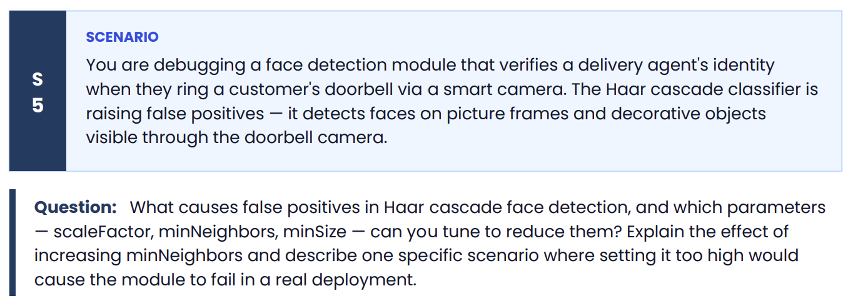
Why Haar Cascades Produce False Positives
Haar cascade classifiers detect faces by scanning an image at multiple scales and positions, checking whether local pixel-intensity patterns match a set of trained Haar-like features (rectangular light/dark contrast patterns representing eyes, nose bridge, cheekbones, etc.). Because this is a statistical pattern-matching approach on intensity gradients, not true semantic understanding, it produces false positives when:
- Coincidental pixel patterns resemble face-like contrast structures — a picture frame with a photo inside, a decorative mirror, wall art, patterned wallpaper, or even shadows/lighting can accidentally create the light-dark rectangular patterns (e.g., eye-like dark regions above a nose-like lighter region) that the cascade's weak classifiers were trained to respond to.
- The cascade's early stages are deliberately lenient — Haar cascades work as a rejection cascade: early stages are fast and permissive (designed to reject obvious non-faces quickly) while later stages are stricter. Some non-face regions with a passable resemblance can slip through several stages before finally being rejected — or, depending on tuning, might pass all stages if the resemblance is close enough.
- Scale and neighborhood settings are too permissive — scanning at too many scales or accepting single-detection windows without corroboration increases the chance a spurious match survives.
- Low resolution, poor lighting, or camera glare on the doorbell footage can degrade actual face detail while accidentally producing ambiguous gradient patterns on flat/reflective objects (glass-framed photos, glossy decor) that resemble faces at a distance.

Tunable Parameters to Reduce False Positives
1. scaleFactor
- Controls how much the image is scaled down between each detection pass (e.g., 1.05 = 5% reduction per step, 1.3 = 30%).
- Smaller values (closer to 1.0, e.g., 1.05) scan more scales → more thorough, more chances to detect real faces at various distances, but also more chances to pick up false positives, since more scale variants of a decorative object might coincidentally match.
- Larger values (e.g., 1.3+) skip more scales → faster, fewer false positives, but risk missing real faces that fall between the coarser scale steps — especially relevant since a delivery agent's face size will vary with how close they stand to the doorbell.
2. minNeighbors
- After the cascade produces raw candidate detections, this parameter controls how many overlapping/nearby detections must cluster together at roughly the same location before it's confirmed as a real face.
- Effect of increasing minNeighbors: Requires stronger consensus among overlapping detection windows before accepting a region as a face → significantly reduces false positives, since spurious matches on a picture frame or decor item are typically inconsistent (they might trigger a detection at one scale/position but not consistently across many overlapping windows), whereas a real face reliably triggers many overlapping positive detections.
- This is usually the most effective single parameter for cutting down false positives like the ones described (static decorative objects), because real faces produce dense, consistent detection clusters while incidental pattern matches tend to be sparse and inconsistent.
3. minSize (and maxSize)
- Sets the minimum (and optionally maximum) pixel dimensions a detected region must have to be considered.
- Since you know the approximate expected face size based on the doorbell camera's fixed distance to a person standing at the door, you can set minSize to exclude small, distant, or irrelevant regions (e.g., a small picture frame further back in a hallway) and maxSize to exclude implausibly large detections (e.g., glare regions filling most of the frame).
- This directly filters out false positives from objects that are the wrong size to plausibly be a person's face at the doorbell's typical detection distance.

Trade-off: Setting minNeighbors Too High
Increasing minNeighbors reduces false positives by demanding more corroborating detections — but pushed too far, it starts rejecting true positives too, because it demands a level of detection consistency that even genuine faces may not always achieve, especially under non-ideal conditions.
Specific Failure Scenario in Real Deployment
Scenario: A delivery agent rings the doorbell at night or during heavy rain/backlight (sun behind them, or porch light causing glare/shadow across half their face). The face is partially obscured — perhaps by a face mask, hoodie, umbrella, or simply an awkward angle as they lean toward the camera and speak into the intercom.
If minNeighbors is set too high (e.g., 15-20 instead of a moderate 5-8):
- The partially-occluded or poorly-lit face produces fewer, weaker, less-overlapping raw detections than a clear, well-lit, fully-visible face would.
- Because the quantity of overlapping positive detections needed to pass the threshold is so high, the genuine face fails to accumulate enough neighboring detections to be confirmed — the system doesn't detect a face at all.
- Result: the identity verification module fails to recognize the delivery agent is present, potentially blocking or delaying delivery confirmation, forcing a fallback to manual verification, or worse, causing the system to silently fail with no face detected and no clear error state — a frustrating real-world failure precisely when the system is needed most (rain, night delivery, agent in a hurry).
This illustrates the core trade-off: minNeighbors trades false positive suppression for detection sensitivity. Tuning it purely to eliminate the picture-frame false positives (a benign nuisance) risks over-correcting into missed real detections (an operationally serious failure) — especially since real-world doorbell conditions (varying light, angle, partial occlusion, weather) are far less ideal than a controlled testing environment where the false-positive tuning likely happened.
Better approach in practice: Rather than pushing minNeighbors to an extreme, combine a moderate minNeighbors value with minSize/maxSize constraints (since decorative objects are often a different apparent size than a face at typical doorbell distance) and, ideally, supplement or replace the Haar cascade with a more robust deep-learning-based face detector (e.g., MTCNN, RetinaFace, or a lightweight CNN), which is far less prone to this kind of fixed-pattern false positive and degrades more gracefully under partial occlusion or poor lighting — a strong argument for revisiting the "Haar cascade only" approach given how safety/access-critical this identity check is.

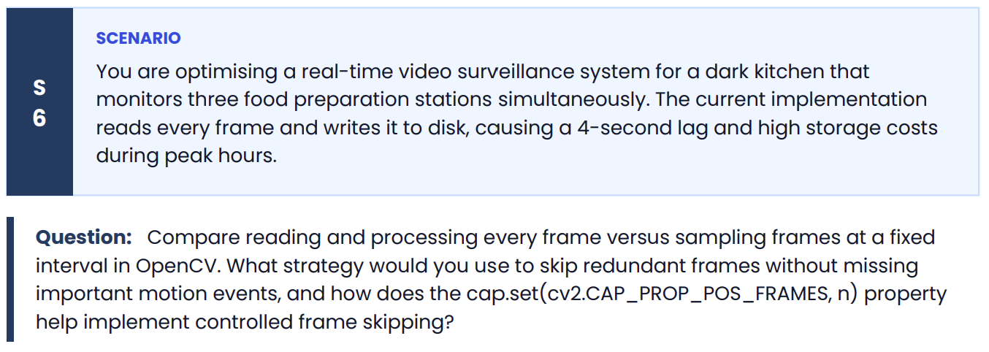
Every Frame vs. Fixed-Interval Sampling
Processing every frame:
- Pros: No risk of missing any event; captures every moment of motion with full temporal resolution.
- Cons: At typical 25-30 fps across 3 camera stations, this means processing/writing 75-90 frames per second combined — most of which are visually near-identical (nothing changed between frame N and N+1 during idle periods). This wastes CPU/GPU cycles, disk I/O, and storage bandwidth, which is almost certainly the root cause of the observed 4-second lag and high storage costs. Writing every raw frame to disk is especially wasteful since dark kitchen stations have long idle stretches (no chef present, no motion) interspersed with bursts of activity.
Fixed-interval sampling (e.g., process every 5th or 10th frame):
- Pros: Dramatically cuts processing/storage load — e.g., sampling every 10th frame at 30fps reduces load by 90%, directly addressing the lag and storage cost problem.
- Cons: It's a blind, uniform reduction — it doesn't distinguish between idle periods (safe to skip heavily) and active periods (risky to skip, since a fast hand motion or a critical safety event like a spill or flame could occur between sampled frames and be missed entirely). Fixed intervals also don't adapt to variable activity levels across the three stations — one station might be mid-prep (high activity) while another is idle, but a global fixed interval treats them identically.
The core trade-off: fixed-interval sampling solves the performance problem but reintroduces risk of missing important events — which matters for a kitchen monitoring system where the "important" data isn't the constant stream but the actual food-handling actions.

Strategy: Adaptive Frame Skipping Based on Motion Detection
Rather than a purely fixed interval, the better strategy combines a cheap motion-detection gate with adaptive frame skipping:
- Baseline sparse sampling — Process at a low fixed rate by default (e.g., every 5th frame) to establish a lightweight "heartbeat" so the system stays responsive even during idle periods.
- Motion-triggered dense sampling — Use a lightweight, fast motion detector between sampled frames to decide whether to increase sampling rate:
  - Frame differencing: cv2.absdiff() between consecutive sampled frames, thresholded, to compute how many pixels changed.
  - Background subtraction: cv2.createBackgroundSubtractorMOG2() (or KNN variant) maintains an adaptive background model per station and flags foreground motion — well suited to a kitchen where the "background" (counter, equipment) is mostly static and hands/food are the moving foreground.
  - If motion exceeds a threshold → temporarily drop back to processing every frame (or near-every-frame) for that station until motion subsides, to avoid missing the actual event (e.g., a spill, a knife cut, a hygiene lapse).
  - If motion is below threshold (idle) → skip more aggressively (e.g., every 10th–15th frame), since nothing is happening worth capturing at full resolution.
- Per-station independent adaptation — Since the three stations are monitored simultaneously, each should have its own independent motion-gated sampling rate rather than a single global rate, since activity is asynchronous across stations (this also helps balance overall system load — not all three stations are typically busy at once).
- Event-based storage instead of continuous storage — Only write to disk clips around motion-triggered events (with a few seconds of pre/post buffer, using a rolling in-memory frame buffer) rather than writing every processed frame continuously. This is likely the single biggest lever for the "high storage costs" part of the problem, since most stored footage from continuous writing is idle/redundant.
This hybrid approach gets the storage/compute savings of interval sampling during idle time, while preserving near-full-frame-rate fidelity during the actual motion events that matter — directly resolving both the lag (much less per-frame work on average) and the storage cost (far less redundant footage retained) without creating blind spots.

Role of cap.set(cv2.CAP_PROP_POS_FRAMES, n)
This property lets you jump the video capture's read pointer directly to a specific frame index n, rather than sequentially calling cap.read() for every frame in between.
How it helps implement frame skipping:
python
frame_interval = 5
frame_idx = 0

while cap.isOpened():
cap.set(cv2.CAP_PROP_POS_FRAMES, frame_idx)
ret, frame = cap.read()
if not ret:
break

# process this sampled frame
process(frame)

frame_idx += frame_interval
Instead of decoding and discarding every intermediate frame with repeated cap.read() calls, CAP_PROP_POS_FRAMES tells the decoder to seek directly to frame n, in principle avoiding the decode cost of the skipped frames.
Important caveats/limitations for this specific deployment:
- Works reliably on video files, not always on live RTSP/camera streams. For a real-time surveillance system reading from live doorbell/kitchen cameras, CAP_PROP_POS_FRAMES is often unsupported or unreliable on live streams, since there's no fixed frame index to seek to on a continuous live feed — the property is really designed for pre-recorded video files with a known frame count/index.
- Seeking accuracy depends on codec — for compressed video (H.264, etc.), true random-access seeking to an exact frame can be imprecise because decoding often requires starting from the nearest keyframe (I-frame) and decoding forward, so cap.set() might not land exactly on frame n and could still incur decode cost for frames between the keyframe and n.
- For live camera capture, the more practical equivalent is manual frame-counting with conditional processing — i.e., still calling cap.read() every frame (since you can't skip decoding on a live stream) but only processing every Nth frame:
python
frame_idx = 0
while True:
ret, frame = cap.read()
if not ret:
break
if frame_idx % frame_interval == 0:
process(frame)
frame_idx += 1
This still incurs the (cheap) frame grab cost for skipped frames but avoids the expensive part — motion detection, inference, disk writes — for skipped frames, which is where the actual performance savings come from in a live surveillance context.
Practical recommendation for this deployment: Given the system reads from live cameras (not files), CAP_PROP_POS_FRAMES-based seeking is less applicable than the counter-based conditional-processing pattern above, combined with the motion-gated adaptive sampling strategy described earlier — that combination is what will actually resolve both the 4-second lag and the storage cost issue.

